**Day 2 Lab Assignments**

**Please do the following assignments:**

1. Create array that contain some tips about JavaScript (Array of 10 strings, each string is tip about JS), and show random tip for the user each time he opens the page "Tip of the day".
2. Make a button that display the current date and time in local format on the page.
3. Ask the user to enter his Email, and use function strings (Don’t use RegExp) to check if the Email contains @, and not in the first or last index.
4. Create an array of numbers and use forEach to calculate and print the sum of all numbers.
5. Create an array of objects representing products, each with properties name and price. Use for...of to calculate and print the total price of all products.
6. Create an array that hold the following students grades : 60, 100,10,15,85, and handle the following:
   1. Sort the array numerically descending.
   2. Using the sorted Array find the highest student degree (first degree less than or equal to 100) [Use find()].
   3. Print the grades of all students with grades below 60 [Use filter()].
7. Create an array of objects representing people with properties name and age
8. Write a function that removes and returns the first person.
9. Write a function that adds a new person to the beginning of the array.
10. Write a function that filters people whose names have a length greater than a given number.
11. Write a function that finds a person by their name.
12. Write a function that filters out people who are 18 years old or older.
13. Write a script that reads from the user his info; validates and displays it with a welcoming message with today’s date. take his choice via prompt.

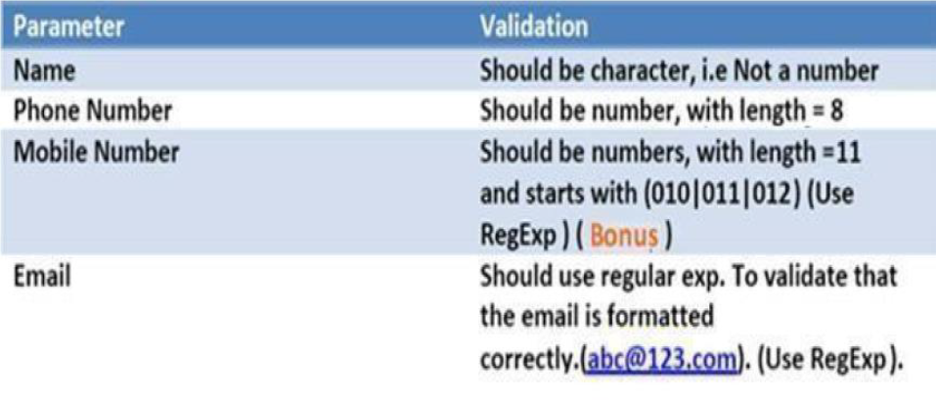

**Bonus assignments:**

1. Show prompt that ask user to enter his birth date and tell user to enter the date in the following format (DD – MM – YYYY) ex. 22–01–1999, and then create function that take user input as a parameter and ensure that the string is entered in this format (that user entered string is 10 characters and contains (-) after the second character and after fifth character).[Don't use RegExp, use string functions].
   1. If the user input was correct: make the function create new date object, and initialize it with Day, Month, year values (using date constructor: Date(y,m,d)) and then show alert to the user with the date in date string format.
   2. If user input wasn't correct, show alert saying "Wong Date Format".
   3. Create button “show date” that calls the function.

**<Script> document.write(“Thank YOU”) </Script>**